LAB 12
INDEXING

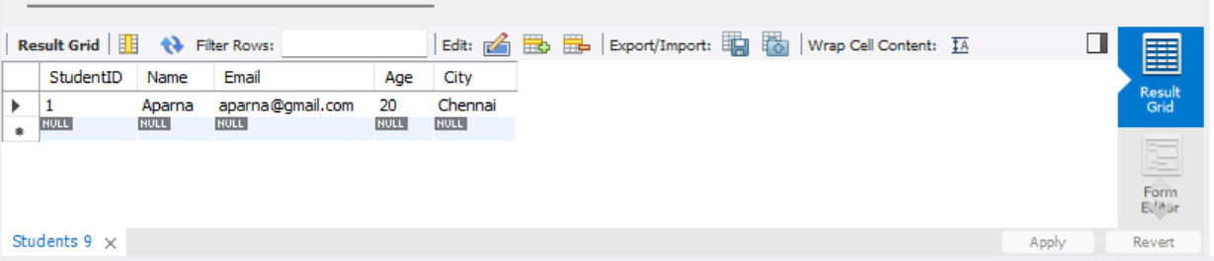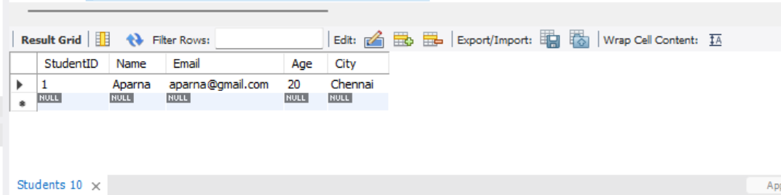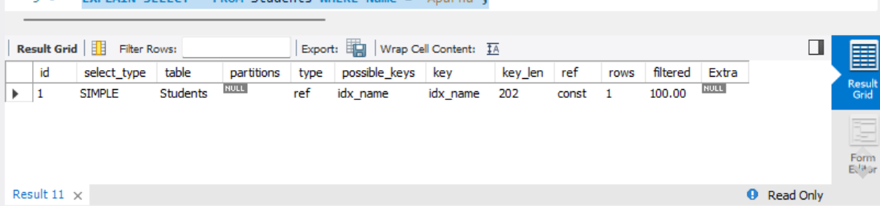
1. Query Before Indexing: Retrieves the student record whose name is Aparna.
2. Create Index: Creates an index named idx_name on the Name column to help speed up searches.
3. Query After Indexing: Retrieves the student record whose name is Aparna using the same query.
4. EXPLAIN: Displays the query execution plan and shows how MySQL retrieves the matching record.
5. Drop Index: Removes the idx_name index from the Students table. The table data remains unchanged.

